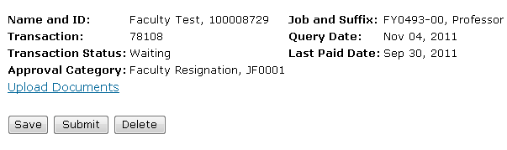

**FACULTY RESIGNATION EPAF**

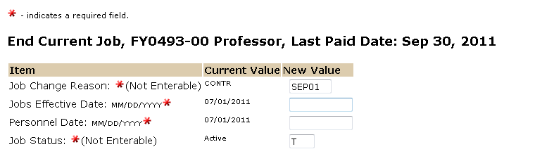

The personnel date is the faculty’s last date of employment.

The Effective date reflects the faculty’s last date of employment.

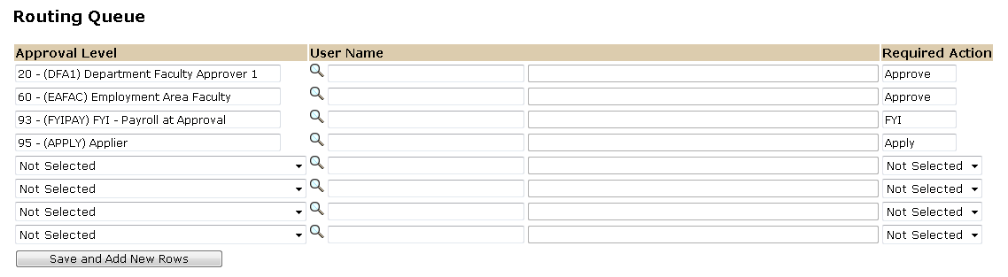

The Required Action field identifies the appropriate action needed by the user.

The User Name is the person/entity associated with a specific approval level

Approval Levels are pre-defined as a standard for system routing. If you require a second level approver, or an FYI as needed.

Use the comment box to document:

* Annual leave balances (less usage for the current month) applicable to **FE** and **FY** faculty (.50 or greater). Maximum annual leave payout subject to applicable policy guidelines.
* Resignation reason

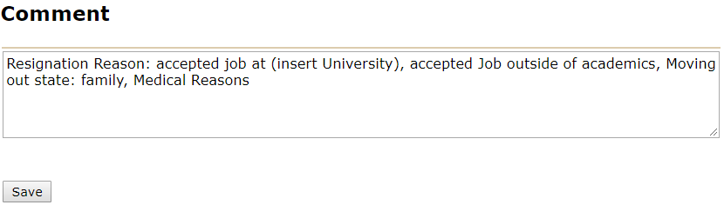

Click the **upload** at the top of the page to attach the Resignation letter and complete your Faculty Resignation EPAF by clicking **save** then **submit**.